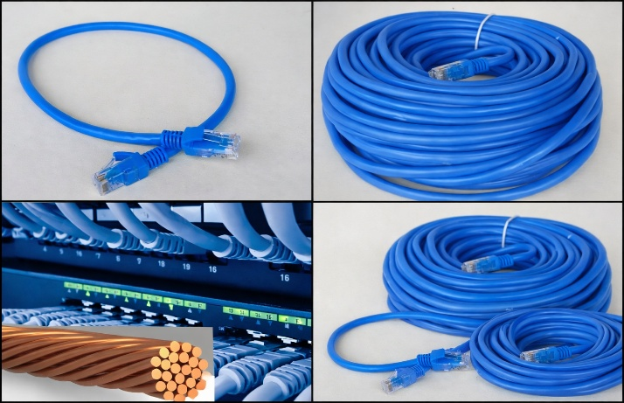

CAT6 Patch Cable 0.25, 0.5, 1.5, 2, 3, 5, 10, 20m

DGT Flow Overview
DGT Flow CAT6 patch cable is designed to provide reliable and high-speed network connectivity for structured cabling systems. It supports stable Gigabit Ethernet data transmission with reduced interference, ensuring consistent performance in residential, office, and SMB environments. With its durable construction and flexible design, the cable is ideal for connecting network devices such as switches, routers, patch panels, and workstations in modern LAN installations.
Functions
CAT6 High-Speed Connectivity
The DGT Flow CAT6 patch cord is designed to support stable and high-speed data transmission for modern LAN environments. It ensures reliable Gigabit Ethernet performance with reduced interference, making it suitable for a wide range of networking applications.
100% Pure Copper Conductor
Manufactured with 100% pure copper conductors, the patch cord delivers excellent electrical conductivity and minimal signal loss. This ensures consistent and dependable network performance across all supported cable lengths.
Factory-Terminated RJ45 Connectors
Each patch cord is factory-terminated with high-quality RJ45 connectors to guarantee precise termination, secure connections, and long-term reliability. This eliminates installation errors and ensures plug-and-play usability.
Stranded Conductor for Enhanced Flexibility
The cable is built with stranded conductors, providing superior flexibility compared to solid CAT6 cables. This design improves resistance to bending and mechanical stress, making it ideal for patch panels, racks, and device connections.

Reliable Performance for Office and Server Environments

Designed for use in office networks, data centers, and server rooms, the patch cord offers stable performance for connecting switches, routers, patch panels, and end devices over short to extended distances.

Technical Specification
CAT6 PATCH CABLE
Sheath Printing | CAT6 PATCH CABLE
Cable | U/UTP (28AWG (BC 7/0.12±0.005)) * 1PRJ * 4 + PVC  OD: 5.8 ± 0.3 mm
RJ45 Connector | RJ45, 8P8C, TWO FORK GOLD PLATED CONTACTS
Molding PVC | MOLDING PVC, 45P  COLOR: Assorted upon request
Packing | 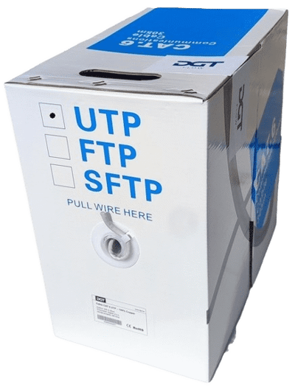
Schematics | 